E-Learning Platform (Shruti)

Abstract
The rapid growth of digital education has created a pressing demand for intelligent, scalable, and user-friendly e-learning platforms. This project proposes the development of a full-stack AI-powered e-learning web application using the Django framework and PostgreSQL for robust data management. The platform enables students and instructors to engage in a dynamic learning environment, supporting features such as course enrollment, lecture management, quiz handling, and progress tracking.
A key differentiator of this platform is its integration with a Large Language Model (LLM) to provide personalized, AI-driven support. The LLM enhances the user experience by offering context-aware course recommendations, real-time doubt resolution, auto-generated performance feedback, and semantic search capabilities across course content. These features not only improve engagement but also create a tailored educational journey for each learner.
The application incorporates role-based access control to manage students, instructors, and administrators, while also providing an intuitive interface for course creation and content delivery. Leveraging Django’s scalability and PostgreSQL’s performance, this platform is designed for deployment in educational institutions, coaching centers, or as a SaaS solution for online learning providers.
By combining modern web development practices with advanced AI capabilities, this project demonstrates how LLMs can be effectively utilized to revolutionize digital learning experiences.

Objective
To design and develop a scalable, AI-driven e-learning web application using the Django framework and PostgreSQL database, enhanced with a Large Language Model (LLM) to provide intelligent course recommendations, student support, and personalized learning experiences.

Technology Stack
- Frontend: HTML, CSS, JavaScript, Bootstrap (Django Templates)
- Backend: Python (Django Web Framework)
- Database: PostgreSQL
- AI Integration: Large Language Model (e.g., OpenAI GPT, Ollama, or LLaMA via LangChain or API)

Key Features
- User Management
  - Role-based authentication (students, instructors, admin)
  - Profile management and progress tracking
- Course Management
  - Create, update, and delete courses
  - Upload lectures, PDFs, quizzes, and assignments
  - Instructor dashboard with course analytics
- Learning Interface
  - View course content and track completion
  - Submit assignments and take quizzes
  - Discussion forum for peer interaction
- AI/LLM-Based Features
  - Course Recommendation: Suggest courses based on past activity and preferences
  - Doubt Support: Natural language Q&A support using an LLM (chatbot or contextual help)
  - Auto-Feedback: AI-generated summaries and tips on performance and quiz results
  - Smart Search: Semantic search through content using LLM embeddings
- Admin Dashboard
  - Manage users, courses, content, and reports
  - Analytics on user activity and course performance

Use Cases
- Personalized learning path recommendations for students
- AI tutor to resolve doubts instantly and interactively
- Real-time analytics for instructors to optimize content
- Scalable platform for schools, colleges, and training institutions

Scalability & Business Value
- Built on Django’s robust MVC architecture
- Easily deployable on cloud platforms (AWS, Heroku, Railway)
- LLM integration provides cutting-edge competitive advantage
- Can be monetized through subscriptions, certifications, or B2B licensing

Future Enhancements
- Mobile app integration (Flutter or React Native)
- Live class scheduling & video streaming
- AI-generated quizzes and flashcards
- Gamification for learner engagement

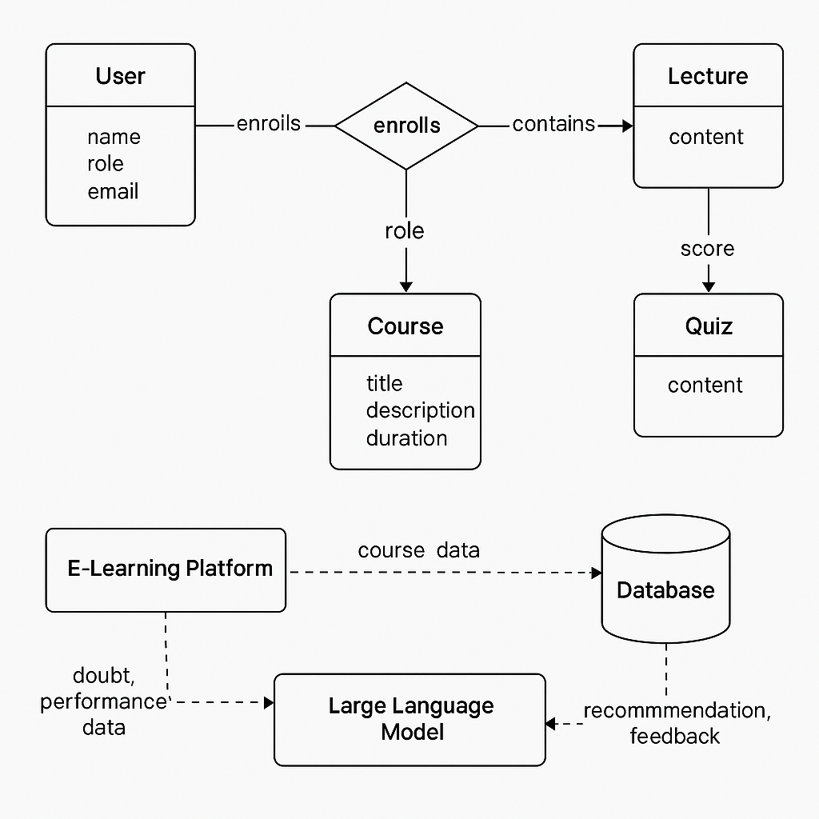

Business Logic for AI E-Learning Platform

1. User Management
Roles:
- Student
- Instructor
- Admin
Logic:
- Users must register and select a role.
- Login credentials are authenticated via Django’s built-in auth.
- Access permissions vary by role:
  - Students: View/enroll in courses, take quizzes.
  - Instructors: Create/manage courses and content.
  - Admins: Full control over users, courses, analytics.

2. Course Management
Entities:
- Course (title, description, instructor, duration)
- Lecture (belongs to Course)
- Quiz (belongs to Course or Lecture)
Logic:
- Instructors can create/update/delete courses and lectures.
- Lectures must be attached to a valid course.
- Quizzes must link to lectures or courses.

3. Enrollment System
Logic:
- Students can enroll in one or more courses.
- On enrollment:
  - A record is created linking the student to the course.
  - Progress tracking starts.
  - LLM starts capturing learning patterns.

4. Lecture & Quiz Flow
Logic:
- Students access lecture content in sequence.
- After each lecture, they can take a quiz.
- Quiz submissions are evaluated and stored.
- LLM receives performance data to personalize learning.

5. LLM-Based Recommendation Engine
Triggered by:
- New registration
- Course completion
- Quiz submissions
- Student questions (doubt resolution)
Logic:
- Based on a student’s:
  - Enrolled courses
  - Quiz scores
  - Learning pace
- The LLM generates:
  - Personalized course recommendations
  - Learning tips or topic explanations
  - Feedback summaries (“Focus more on Django ORM concepts”)
Tools:
- OpenAI GPT, Ollama, or LLaMA via LangChain or API
- Embedded context includes course metadata + user progress

6. Smart Doubt Support (Chatbot)
Logic:
- Students ask questions in natural language
- LLM responds with explanations, examples, or resources
- If a query relates to a course topic, it retrieves relevant lectures/quizzes

7. Admin Dashboard
Logic:
- Admins can:
  - Add/remove users and instructors
  - View reports of top-performing students
  - Moderate discussion forums or AI feedback
- Dashboard includes analytics on:
  - Course engagement
  - Completion rates
  - Quiz pass/fail ratios
  - LLM usage logs

8. Data Flow
- User interacts via web UI
- Django views/controllers handle form submissions
- Data is validated and saved to PostgreSQL
- LLM functions are triggered asynchronously (or synchronously)
- LLM returns results → stored in DB → rendered on frontend

9. Security & Validation
- CSRF protection on all forms
- Input validation at model + form level
- LLM responses are filtered for safety (if needed)
- Permissions enforced using Django’s @login_required and custom middleware

10. Optional Enhancements
- Celery + Redis for background LLM tasks
- Stripe/PayPal for course payments
- Certificate generation after completion
- Gamification layer: points, badges, ranks

